**Prepreg Autoclave Hand Lay Up**

**Woven carbon fabric prepreg**

McLaren Automotive (Design) Prodrive Composites (Manufacture) Rear Clamshell



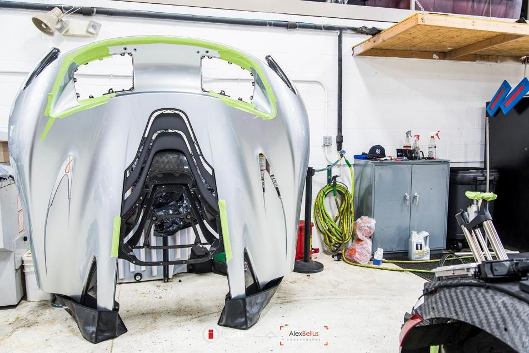

Requirement – Very low weight, surface finish with thin paint, very high stiffness for robust feel and aerodynamic loads

Material –Woven Intermediate Modulus prepreg (with additional UD tape and PMI foam core)

Process – Hand lay up, autoclave curing

Key Features –

Very complex and large shape produced by careful hand laminating

Single sided multi-part tool allows a very deep and large shape with undercuts

Reduced assembly cost through moulding a large complex part – bonding labour time and the cost of a large jig is eliminated

Reduced warpage vulnerability through moulding a large complex part

Extreme Lightweighting through thin plies thickness optimisation and Intermediate Modulus (IM) carbon fibre

Extremely high quality surface finish through high autoclave pressure and resin rich low thickness tow prepreg

### Difficulties –

Very skilled laminators required to avoid wrinkling

Very low materials deposition rate and hence very high cycle time

Split line between tool sections causes a resin ridge needs to removed by hand sanding

Relatively high cost tooling to provide stiffness during cure for a large shape

Very Approximate Manufacturing Cost – Labour £1500, Materials £600 Tooling £50000 Total £2200